January 12, 2015

oshw.it

manual written by salvatore balestrino

Italy

Hackerbot manual

v2.0 rev.1

# THIS IS A BETA VERSION

Notice

The information in this document is subject to change without notice.

NO WARRANTY OF ANY KIND WITH REGARD TO THIS MATERIAL, INCLUDING, BUT NOT LIMITED TO, THE IMPLIED WARRANTIES OF MERCHANTABILITY AND FITNESS FOR A PARTICULAR PURPOSE.

We are not be liable for errors contained herein or for incidental or consequential damages in connection with the furnishing, performance, or use of this material. This equipment has been tested and found to comply with the limits for a Class A digital device, pursuant to part 15 of the FCC Rules. These limits are designed to provide reasonable protection against harmful interference when the equipment is operated in a commercial environment. This equipment generates, uses and can radiate radio frequency energy and, if not installed and used in accordance with the instruction manual, may cause harmful interference to radio communications. Operation of this equipment in a residential area is likely to cause harmful interference in which case the user will be required to correct the interference at his own expense. Changes or modifications to the machine system not expressly approved, the party responsible for compliance, could void the user’s authority for use. All rights reserved. All part of this document may be photocopied, reproduced or translated into another language without the prior written consent

System conforms with the following standards, in accordance with the EU Machinery, Low Voltage and Electromagnetic Compatibility Directives: EU 89/392/EEC, EU 98/37/EEC, EU 73/23/EEC amended by 93/68/EEC, EU 89/336/EEC

Contents

Introduction 5

Before you start 6

Tools you need to assemble the printer 6

Technical specification 7

Safety 8

Used symbols 8

Installation 9

Assembly 10

Machine overview 10

Bill of materials 11

Drawings 12

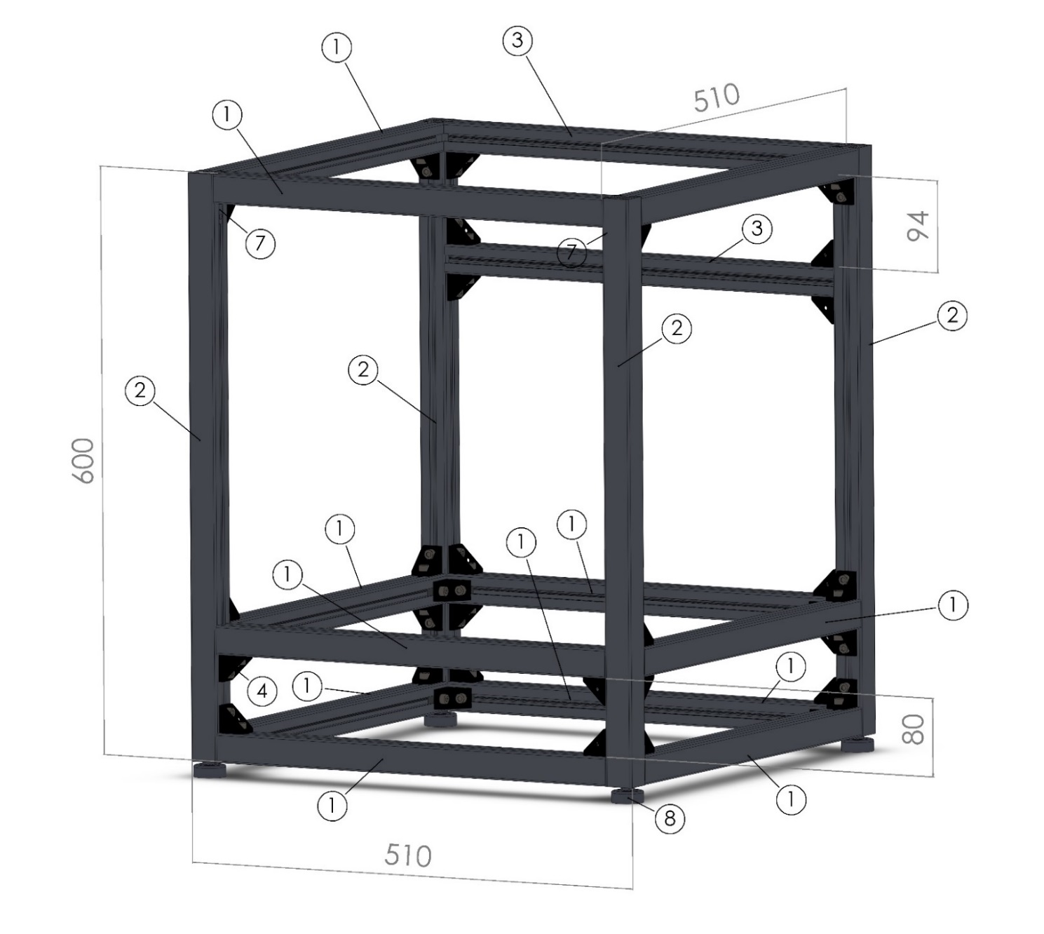 12

# Introduction

To ensure the packaging machine lives up to all expectations, it is important to read and comply with this instruction manual. Please store this manual near the machine for easy access, as it is an important resource for all personnel involved with the operation and maintenance of the machine.

This manual provides personnel with the information needed to safely operate and maintain the machine. It has been designed and written to be used as an instructional tool, as well as a reference tool, for everyday work. To improve understanding by all levels of users, step-by-step instructions are provided where possible. Important tags mark information about the best ways to operate the machine, and this information can be valuable in maximizing the production and longevity of the machine.

It is important that all personnel read and understand the Safety Chapter BEFORE operating the machine. Also, read all Warning and Caution notices at the beginning of each chapter BEFORE attempting to make any adjustments or changes. Warning and Caution notices are also positioned in strategic areas throughout the manual to point out any hazards that may arise from machine setup and/or adjustment procedures

Both the User Manual and the Build Manual also include an ordering guide for assistance when ordering parts. To gain the most from the machine, always use genuine parts.

Visit <http://www.opensourcehardware.it> for more information about equipment and parts.

**Illustrations may be changed without notice.**

**All dimensions and specifications are approximate and drawings are not to scale.**

**Machines are shown without guards for illustration only.   
Guards are supplied and must be in place before operation.**

**Sales are subject to prevailing terms and conditions of sale.**

**Specifications are subject to change without notice.**

## Before you start

Our advice is to first carefully check if all the steps are clear and you have the necessary tools

We assume that those who go to assemble the printer has a bit of practice with the mechanics and electronics.

Remains necessary that the connections of parts with voltages above 24V needs to be made to qualified persons.

Please check and comply to your local regulations.

There is a forum dedicated to assembly help [here](http://oshw.it/projects/hackerbot/boards/1)

### Tools you need to assemble the printer

* Allen key set
* Small flat screwdriver
* 10mm wrench
* Vernier caliper (small one and big one)
* Cutters

## Technical specification

* Name: Hackerbot
* Model/type: v2.0
* Year of production: 2015
* Print area: 300x200x200mm
* Dual Modular Head
* High quality aluminium frame and parts
* Easy of use with Touchscreen or Big LCD display & SD Card
* WiFi connectivity optional: connect with tablet
* know printable materials: ABS, PLA, HIPS, Nylon, rubber*
* 3.0A stepper drivers
* Weigth: 28Kg
* Power supply: 110V-230V 50-60Hz
* Operating system: Windows, MAC and Linux
* Speed: Max. head travel speed between 30mm/s - 300mm/s.
* Accuracy: Positioning < 0.05mm
* Technology: FFF (Fused Filament Fabrication)
* Ambient Operating Temperature: 15° - 32° C
* Storage Temperature: 0° - 32° C

The machine can only be used in a dry environment.

The product cannot be used in a humid environment and in an environment with lots of UV light.

Usage in other environments can result in unwanted effects on the performance of the product.

# Safety

Safety depends on everyone who operates, maintains, services, or works nearby operating equipment.   
Any person involved with the operation of this equipment should be familiar with the following dan­ger, warning, and caution notices.

Personnel should **NOT** operate this machine until trained on its func­tion and purpose.

Liability is limited to operation using the original program. Machines are shown without guards for illustration purposes only

## Used symbols

 WARNING! A warning indicates the risk of (serious) damage to the user or the product if the user does not carry out the procedures with care.

 CAUTION! A comment makes the user aware of possible problems

 NOTICE: A notice makes the user aware of convenient functions and additional options.

## Installation

Only trained machinery movers, using appropriate and well-main­tained equipment, should handle, move, and install the machine.

Please refer to the chapters in this manual for complete instruction and safety information.

Guards or covers are supplied with the machine and must be in place before operation begins.

**NEVER** bypass or disconnect safety switches. Doing so could greatly increase the chance for personal injury.

Machine location must provide sound footing, adequate lighting, and accessibility from all sides.

**DO NOT** install the machine in a combustible environment or near combustible or explosive material.

Keep the area around the machine clean and free of obsta­cles to avoid injuries due to falls.

## Precautions

* **NEVER** touch or repair components while they are hot. If heat compo­nents must be handled, use insulated gloves and mechanical devices where practical.
* Only use original accessories from the manufacturer.
* The product should only be used for applications as described by the manufacturer. All other applications are unprofessional and considered dangerous. The manufacturer cannot be held liable for damage resulting from errors, unintended or unprofessional use of the device.
* Do not install the product outdoors or in any place where it might become wet.
* Do not install the product in any place that might be exposed to extreme heat or cold.
* Keep the product out of reach of children.
* Disconnect the device from all power sources before cleaning it.
* Remove the adapter from the power outlet during storms, lightning and whenever the product will not be used for a longer period of time.
* Install the product as indicated in this manual. If in doubt, consult a recognized technician and always take account of local installation codes and regulations.
* The product should be kept out of direct sunlight.
* The product must not be discarded as unsorted municipal waste, it must be disposed of separately.
* Find out about the options in your region for disposing of the product after use. Do not throw away electrical appliances or components, but see whether the product (components) can be turned in, recycled or reused.

# Assembly

## Machine overview

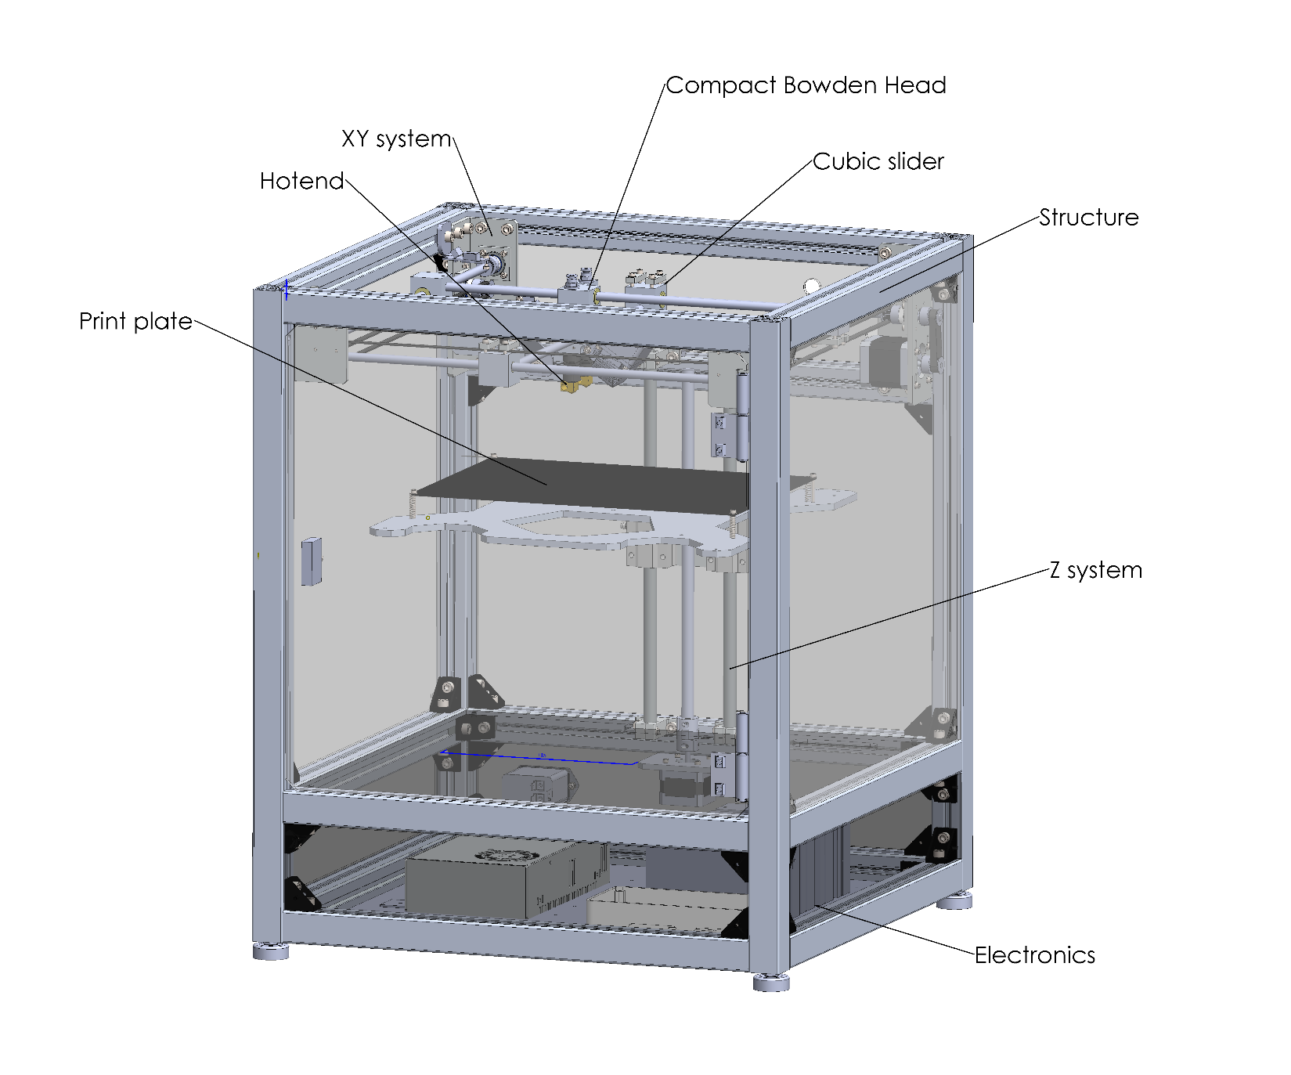

|  |  |  |  |
| --- | --- | --- | --- |
| ref | Part name | description | qty |
| 1 | EFSFB6-3030-450 | 30mm 3slot aluminum extrusion  450mm | 11 |
| 2 | EFSTB6-3030-600 | 30mm 2slot aluminum extrusion  600mm | 4 |
| 3 | EFSB6-3030-450 | 30mm aluminum extrusion 450mm | 2 |
| 4 | HBLFSB6-C | Black aluminum bracket (30mm) | 40 |
| 5 | HBLBS6 | Internal bracket 8mm slot | 2 |
| 6 | FBF33-8-30 | rubber foot | 4 |

## Bill of materials

Tools needed:

## Drawings

## 